# AI Assisted Coding - Lab Test – 1

* Name – G.Sanjansah ,
* Date – 01-09-2025
* Subject – AI Assisted Coding
* Hall Ticket Number – 2503a52l20
* Student Mail Id – [2503a52l20@sru.edu.in](mailto:2503a52l20@sru.edu.in)

Q1. AI-Assisted Code Optimization [5 M]

● Task: Write a prompt to generate a Python program for sorting a list of numbers using AI tools.

● Then re-prompt the AI to optimize the code for better performance (time complexity).

● Requirement: Submit both versions of the code and explain which one is more efficient and why.

Prompt :

Code :

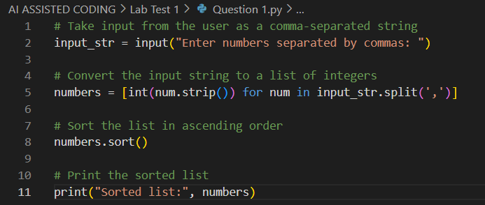

Output :

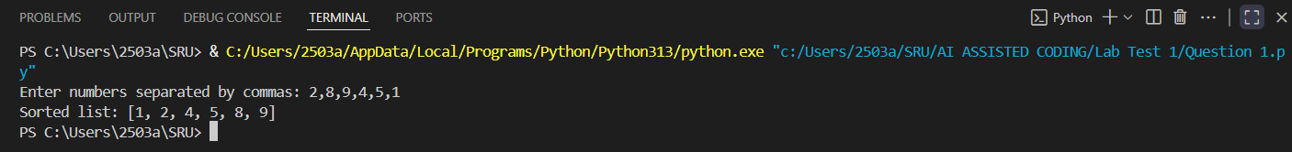

Observation :

Improved Prompt :

Code :

Output :



Observation :

Q2. Multi-Stage Code Generation [5 M]

● Task: Ask AI to generate a Python program for Fibonacci series.

● Then re-prompt AI to modify the program so that it:  
1. Accepts user input (n terms).  
2. Uses functions to improve modularity.

● Requirement: Submit both versions of the code and explain how re-prompting improved the program.

Prompt :

Code :

Output :

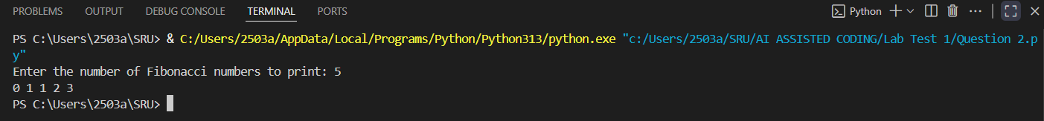

Observation :

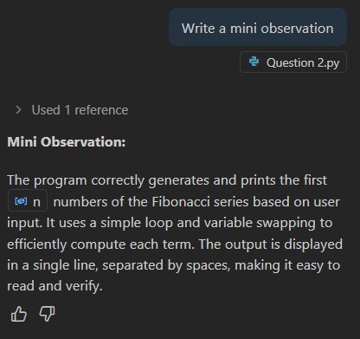

Improved Prompt :

Code :

Output :



Observation :

